**COMP 3074 Lab Ex4**

Build a mobile app that shows a map centred to the location of the user.

**1.Permission Check**

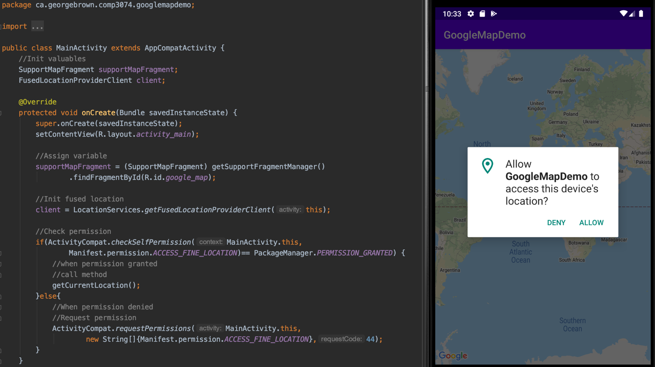

**2.Get User Current Location**

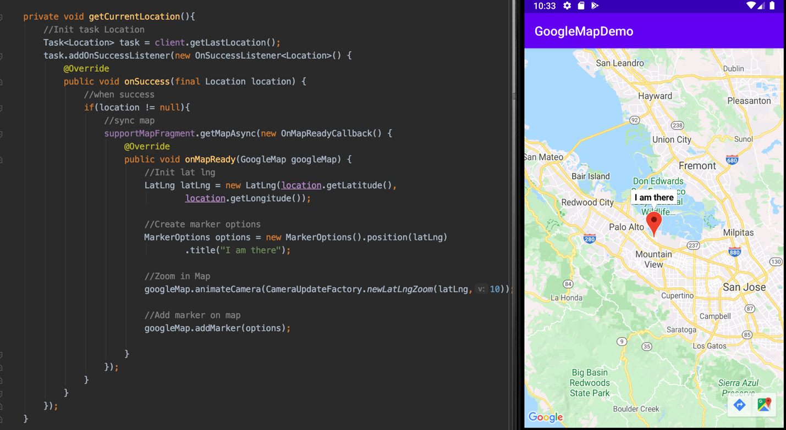

**GitHub Source Code Repository:**

<https://github.com/linminca/comp3074_lab_project/tree/master/wk5>

**Reference:**

**Android Coding**

<https://www.youtube.com/watch?v=p0PoKEPI65o&ab_channel=AndroidCoding>